

**BUSA 511: Assignment Coversheet**

Assignment for Course:      BUSA 511: Business Analytics for Managers

Submitted to:                 Dr. William J. Harris

Submitted by:             Banda, Ruthvik Rajan

                                       Collins, Gary

Dobbins, Laura

Harshadbhai Patel, Vishal

Luphahla, Tapuwanashe

Date of Submission: 10/09/2022.

Title of Assignment: **Team Time Series Forecasting Project**

CERTIFICATION OF AUTHORSHIP: W certify that We are the authors of this paper and that any assistance received in its preparation is fully acknowledge and disclosed in the paper. We have also cited any sources from which we used data, ideas of words, whether quoted directly or paraphrased.  We also certify that this paper was prepared by the team specifically for this course.

*******************************************

Professor’s Grade on Assignment:

Professor’s Comments:

**Team Time Series Forecasting Project Instructions**

***Instructions***

This is a team assignment and therefore must be completed by the assigned team members together without outside assistance of any type. Follow the instructions below to complete the assignment:

* **Part 1.** First, download and read the case write-up for the *Cutting-Edge Case Study on Forecasting* found in the Microsoft Word file “**Case Study for Team Forecasting Project.docx**”. Enter your answers for Part 1 below and refer to the information leading up to the opening of the new call center.
* **Part 2**. Second, download the Excel file “**Cutting Edge Student File No. 1.xlsx**” and enter your answers for Part 2 below and refer to the first 13 weeks of operation after opening the call center. Each model calculation should include a week 14 forecast for every day of the week (Cells G71-75).
* **Part 3**. Finally, based on your analytic analysis and use of the models in part 2, answer the questions and provide a short (about two pages) recommendation to include an original graphic. The graphic should present an important point the team would like to make.

***Submittals***

1. Submit your answers to this assignment (parts 1, 2 snf 3) using this Microsoft Word document and post to the assignment drop box before the required deadline. Be sure to complete the above first page cover sheet. Enter your answers in the pages below to include all of your answers and results of your interpretations of calculations for the assignment questions. Your answers must be entered directly into this Word document below each question. Use as much space as needed.
2. Submit your Excel spreadsheet(s) with calculations/ visualizations to the assignment drop box before the required deadline. Your Excel model calculations will be used to substantiate your answers to the assignment questions herein.

***Grading***

This is a team assignment, and all members of the team shall receive the same grade unless any team member(s) does not provide agreed upon contributions as determined by the Peer Review. A total of 100 percentage points is possible for this assignment. This includes the point values which are assigned to each question - point values are noted next to each question below. Use APA 7 writing style as a guide for answers that require a written explanation. Up to 10 points will be deducted from the combination of written explanation answers that are poorly written. Do not use underlines, highlights or italics for any part of your written answers unless provided in this template. The percentage points earned on this assignment will be multiplied by 20 to obtain the final assignment grade.

**Part 1 (15 points)**

In written explanations answers for part 1, reference the Cutting-Edge case study file: “**Case Study for Team Forecasting Project.docx**”

***Question 1a*** (5 points): Define a problem statement which reflects the challenge facing Mark as he planned for the opening of the new center.

**Answer**:

As the challenges faced before with lack of coordination between the employees and high operating costs, Mark wanted to combine all the 35 separate centers under one single platform “administrative center”. As the employees are perplexed about their responsibilities and unaware of handling the service call to their customers make the situation erratic which would, in turn, lead to the rise of complaints. Therefore, Mark wanted to standardize procedures and have centralized data where employees are trained and staffed appropriately to serve and improve the business scenario with minimal operating costs.

***Question 1b*** (5 points): Why was Mark’s initial approach to forecasting call volume so far off? What could have been the reasons for this?

**Answer**:

Mark failed to choose the ideal sample size for his forecast, out of 35 distinct centers he had to consider only one center for his forecast study and the outcomes are distressing. Judgmental forecasting is basically a qualitative assertive analysis where Mark, out of his renowned experience with no quantitative analysis backup to support his decision made the forecast model failed miserably. Qualitative analysis has no dimensions and is based on one’s expertise making Mr. Mark overlook the whole scenario.

***Question 1c*** (5 points): What could Mark have done differently to improve his initial forecast?

**Answer**:

Mark underestimated the call volume by not considering the past call history data for each day in a week to forecast for another week. Mark would have considered overall sample data acquired from all 35 centers leading to one larger sample dataset. Depending on the average calls handled by each center would have made Mark think in a different way so that he can access the call volume on an average and the number of employees required to handle them. When he approached Harry for an accurate forecast, then Mark handed out the operational data of the call center, where Harry forecasted different time series forecasting with available history/data which made several outputs to choose the best operating method depending on the MAD value.

**Part 2 (60 points)**

In answering Part 2 questions, download and reference “**Cutting Edge Student File No 1.xlsx**” which contains the data and models to be used in preparing the forecast results for your answers. You will need to review the time-series plot of the 13 weeks of data in the DailyData tab. For each model, copy the data for all 14 weeks into the appropriate method column. Each method will auto-calculate giving you information to analyze and interpret. Note, in answering these questions you **will need to reference lecture charts for method descriptions and utilized the Excel models forecasts for MAD values**.

***Question 2a*** (10 points): Calculate the **Last Value method** forecast using the appropriate Excel model. In your own words, describe the details of the Last Value method and explain its accuracy (MAD value) in comparison with the accuracy of the other methods.

**Method Description Answer**:

Last Value method is the simplest and relatively fastest of all the methods even when applied to larger datasets and has the nearest accuracy when considered in real-time. As in this method, we just focus only on the last value in the sample for predicting the forecast, which is sometimes the easiest method in getting an appropriate forecast for optimization. We use this method when the values in the sample are highly fluctuating and when in the case of unpredictability. When applied with seasonality we try to standardize the values to obtain a smooth curve for the prediction.

**MAD Comparison Answer**:

The Last Value method MAD (i.e,169) is near accurate to Exponential Smoothing with α=0.7(i.e,163) when considered on a daily call volume basis. When compared monthly we still find the Last value method is working best with little variation and is near accurate to the moving average method (MAD=218). On further comparing other methods for their MAD values, it seems to be in low proximity to the given data. So, Exponential smoothening with the lowest MAD defines the best model when considered on a daily call volume basis.

***Question 2b*** (10 points): Calculate the **Averaging method** forecast using the appropriate Excel model. In your own words, describe the details of the **Averaging** method and explain its accuracy (MAD value) in comparison with the accuracy of the other methods.

**Method Description Answer**:

The averaging method uses historical data and averages this data for the forecast.  It is used when conditions are stable, and we do not have fluctuating data.  This method is better to use when the data is similar at each point. Because of the underlying variability in call volume, the averaging method of forecasting ranks last in terms of accuracy. It averages all the data points in the time series.

**MAD Comparison Answer**:

For MAD we used this averaging method, and the MAD was 303.  That is a significant variation compared to the other methods utilized for forecasting.  This is the worst method for this case because of the variation.  Using all data available causes the actual forecast to be higher than the other methods.

***Question 2c*** (10 points): Calculate the **Moving Average method** forecast using the appropriate Excel model. In your own words, describe the details of the **Moving Average** (5 days) method and explain its accuracy (MAD value) in comparison with the accuracy of the other methods.

**Method Description Answer**:

The moving average method data is only the last **n** periods in order to come up with a forecast for the next period. It has the advantage of using recent history and multiple data points in a series to predict the next value. The **n** used and it was 5, meaning that the last 5 days were

used to forecast. The moving average method takes into account the recency and trend of data. The forecast is arrived at by averaging data for the last 5 days in this case and all data points have equal weight. The method has the lowest MAD and hence the most accurate.

**MAD Comparison Answer**:

Critics of this method argue that it may not adapt to a rapidly changing environment since it places the same weight on all the observations chosen. However, moving average ranks first in terms of accuracy, it has the lowest MAD (218) of all the methods considered.

***Question 2d*** (15 points): Calculate the **Exponential method** forecast using the appropriate Excel model. In your own words, describe the details of the **Exponential Smoothing** (alpha = 0.1) method and explain its accuracy (MAD value) in comparison with the accuracy of the other methods.

**Method Description Answer**:

The exponential method is a modified version of the moving average. The most recent observation is assigned a weight and the older observations are assigned a smaller weight. The value of alpha depends on the process stability, A lower alpha signifies a stable process, however, there are a lot of variabilities, and the following formula is used to predict what the next value will be:

**Forecast** = Alpha*(Last Value) + (1-Alpha) * (Last Forecast)

**MAD Comparison Answer**:

In this we used an alpha of 0.1 because he felt like conditions would remain stable. The forecast produced a MAD of 249.

***Question 2e*** (15 points): Calculate the **Exponential method** forecast using the appropriate Excel model. Describe the **Exponential Smoothing** (alpha = 0.7) difference in accuracy (MAD value) in comparison with the accuracy of the answer in 2d.

**Method Description Answer:**

Exponential smoothing is a method used for smoothing a time series in the exponential window function. This method allows for data to be changed, smoothed, after the data is retrieved from the beginning of the data set. Like the value method, this method shows a future trend for the numbers received from the set and it provides more weight in recent months. By using a larger alpha, a more relevant information will be drawn. In this case, response to changing conditions is fast and there is large variability in the output

**MAD Comparison Answer:**

Exponential smoothing with an alpha = 0.7, the MAD value is 163. This method appears to be the most accurate. We will use this method out of all the 5 methods available.

**Part 3 (25 points)**

In addressing Part 3a reference “**Cutting Edge Student File No. 1.xlsx**” which contains the data and completed models that were used in part 2 in preparing the forecast results and model accuracy. **You will need to analyze and interpret the Excel forecasts from part 2 – no additional calculations are needed**.

***Question 3a*** (25 points): Based on the answers above, complete the forecast vs. actual daily call volume table found in the Excel file Summary Values tab and insert the table below. Then, provide your final week 14 forecast and recommendations to the company on daily call volume forecasting to improve the scheduling of the call enter staff. You must recommend and justify a forecasting model as a part of your answer.

**Methods Summary Values Table (3 points):**

**DAILY FORECAST**



**MONTHLY FORECAST**



**Model Selected and Justification (5 points):**

We choose to select Exponential smoothening with Alpha=0.7 to be the ideal model for this scenario. We can have a glance on the Daily Forecast Summary values inserted above, Exponential Smoothening (α=0.7) MAD has the best value when compared to the other models. Considering the Mean Square Error also clearly states that the Exponential Model with Alpha=0.7 is still working the best with the lowest error value. Therefore, we acknowledge Exponential smoothening best fits this scenario. Considering on a Monthly basis still, we find the model to be working satisfactorily and supporting to be an ideal model solution.

**Final Selected Forecast Answer for Each Day (2 points)**:

On this note, after thorough analysis and based on MAD and MSE significance, we select Exponential Smoothing (Aplha=0.7) to be the final forecast model applied to this scenario for each day’s forecast purposes.

**Your recommendations for the company to include at least one original graphic (15 points)**:

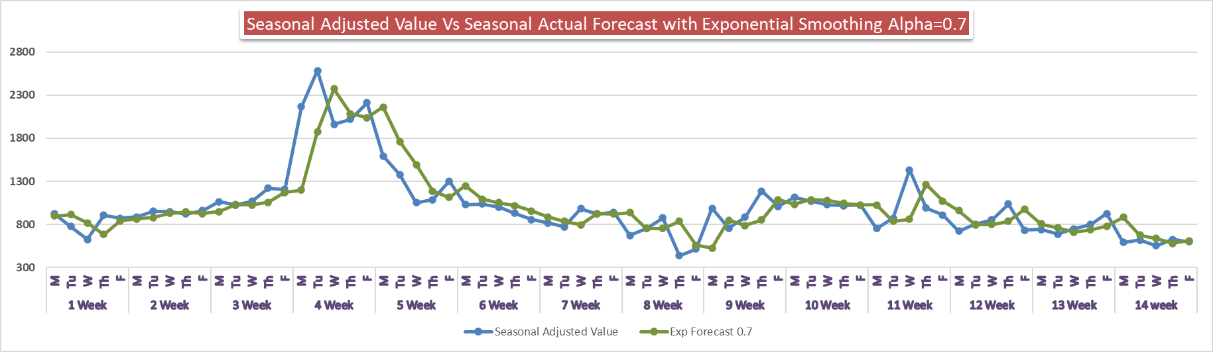

**MAD =163**

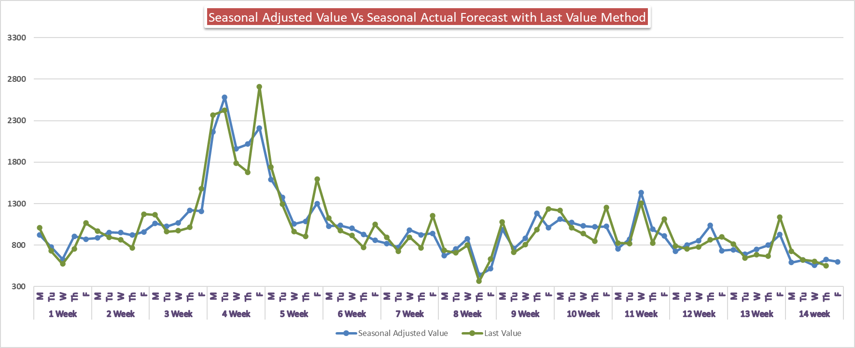

**MAD =169**

Judgmental forecasting set off a chain-reaction of unintended consequences. Mark’s quest for efficiency was overshadowed by his lack of sound data. Human Judgement can provide a significant benefit but also many biases (Lawrence, M; Goodwin, P; O’Connor M & Onkal D. 2006). The biases in judgmental forecasting can lead to stereotyping as the information is purely subjective albeit still considered quantitative.

Cutting edge would be wise to bring in outside help in the form of a Six Sigma black belt in order to increase overall efficiency. To forecast accurately the business should understand seasonality. One of the busiest times for a call center as Cutting Edge is during the period of open season for benefits. During this time, call volume and wait time are extremely high. The business should measure the variance to their norm to quantify what constitutes as a notable shift. They should analyze historical data from open season to forecast the number of calls and the staff that should be on site to satisfy the demand.

Further, on analyzing the facts from the quantitative models MAD & forecast errors values for the Last Value method it looks overestimated on the daily call volume forecast and the forecast error is to be on the higher side than Exponential Smoothing with Alpha 0.7.

I would recommend Cutting Edge review historical data for trends that occur in their call center during peak and non-peak times. The data showed historically that more calls are always received at the first of the week, so they need to plan and staff according for those higher call volume days. Choosing sample data size that considers actual data, quantitative, versus perceived data, qualitative, will always result in true measures. As was found through data examination, the Exponential Smoothing with Alpha 0.7method will be the option of choice to receive the most accurate data for the company and the call volumes of the company fluctuate and are affected by seasonal patterns.

# References

Vuong, R. L. (2020, August 28). *8 Effective Ways to Improve Your Forecast Accuracy*. Retrieved from Fuse Inventory: https://www.fuseinventory.com/blog/8-effective-ways-to-improve-your-forecast-accuracy